
 | HKT-PE BES FRS <Feature Name> v<x.y>
 | Issue | V1.0
 | Date | <YYYY-MM-DD>
 | xxx TECHNOLOGIES CO., LTD.

Address: | xxx Industrial Base  People's Republic of China
Website: | http://www.xxx.com
Email: | support@xxx.com

Change History

Version | Date | Revised By | Section Modified | Description
0.1 | <DD/MM/YYYY> | <Author> | All | Initial draft version.

Contents
1 <Feature Name> 5
1.1 CR Number 5
1.2 Overview 5
1.2.1 Requirement Introduction 5
1.3 Business Rules and Assumptions 5
1.4 Solution Design (CRM/GUI Layout) 5
1.4.1 Solution Overview 5
1.4.2 <Offer/Capability 1> Offer 5
1.4.3 <Offer/Capability 2> Offer 5
1.4.4 <Offer/Capability 3> Offer 5
1.4.5 <Offer/Capability 4> Offer 5
1.4.6 <Offer/Capability 5> offer 5
1.4.7 Subscribe Monthly VAS Offer in SOP 5
1.4.8 Subscribe Monthly VAS Offer in CSP 5
1.4.9 View Usage Entitlement/Spending of <Offer/Capability 5> Offer in CSP/ESP 5
1.4.10 View Offering attributes of Subscribed Offer in CSP/ESP 5
1.4.11 View Subscribed Monthly VAS Offer in CSP/ESP 5
1.5 Solution Design (Integration Context) 5
1.5.1 <Offer/Capability 1> Offer Subscription 5
1.5.2 First Roaming then Subscribe to <offer> Offer 5
1.5.3 Same Day Multiple Day Pass/Top Up Offer Scenario 5
1.5.4 <Offer/Capability 4>/Quota Pass Offer Expiration Handling 5
1.5.5 <Offer/Capability 5> Offer Quota Used Up Handling 5
1.5.6 Cancel S_<Feature Name> Subscription 5
1.6 Solution Design (Interface Specification) 5
1.6.1 <Offer/Capability 4> Subscription 5
1.6.2 <Offer/Capability 5> Subscription 5
1.7 Solution Design (CBS& MDS-C) 5
1.7.1 Rating & Charging 5
1.7.2 Bill Presentation 5
1.7.3 GL Booking 5
1.7.4 Offer Relationship between <Feature Name> day pass and other roaming plan 5
1.8 Impact on the System 5
1.9 Application Limitations 5
1.10 References 5
1.11 Appendix 5
1.11.1 Unified API Interface Specification 5
1.11.2 KJava Interface Specification & Sample 5
1.11.3 CBS API Interface Specification (Notification to <External Platform>) 5

<Feature Name>

CR Number
<CR Number, e.g. PE_CR2026001>

Overview

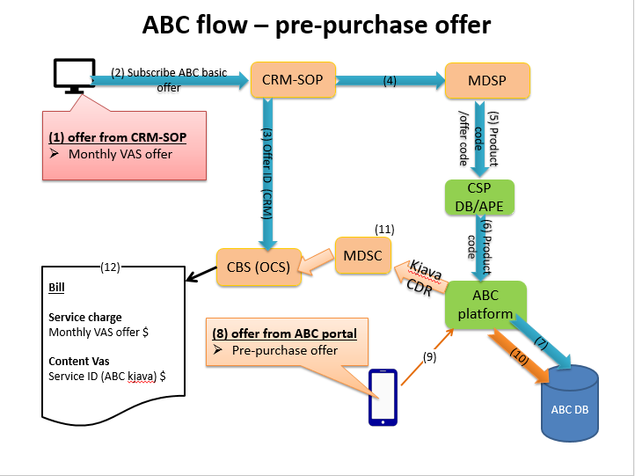

Requirement Introduction
<Describe what the subscriber can do / what offers or capabilities this feature provides.>
- <Offer/Capability 1> – <one-line description>.>
- <Offer/Capability 2> – <one-line description>.>
- <Offer/Capability 3> – <one-line description>.>
- <Offer/Capability 4> – <one-line description>.>
- <Offer/Capability 5> – <one-line description>.>
Refer to following table for the subscription relationship / availability of the above offers or capabilities:
Offer / Capability | Subscribe in SOP/CSP | Subscribe in ESP | Subscribe in <External Platform>
<Offer 1> | <Yes/No + provisioning note> | <Yes/No + provisioning note> | <Yes/No + note>
<Offer 1> | <Yes/No + provisioning note> | <Yes/No + provisioning note> | <Yes/No + note>
<Offer 1> | <Yes/No + provisioning note> | <Yes/No + provisioning note> | <Yes/No + note>
<Offer 1> | <Yes/No + provisioning note> | <Yes/No + provisioning note> | <Yes/No + note>
<Offer 1> | <Yes/No + provisioning note> | <Yes/No + provisioning note> | <Yes/No + note>

Business Rules and Assumptions
Seq. | Rule Name | Rule Description | Remark
1 | Rule_001 | <Describe business rule 1: what CRM/CBS/external system must do.>

Solution Design (CRM/GUI Layout)

Solution Overview
- <Describe the overall CRM/GUI solution: what offers or screens are configured, what the operator sees.>
- <Describe the subscriber-side flow: where they go, what they subscribe.>
- <Describe any alternative channels or channel restrictions.>
- <Describe provisioning / synchronization / notification behaviour between CRM, CBS and downstream systems.>

<Offer / Capability 1>
<Describe this offer/capability: where it lives, its purpose, any batch or restriction rules.>
<Product / offer code: <product name>.>
<Dependency: this offer depends on <parent offer/product> to activate <service>.>

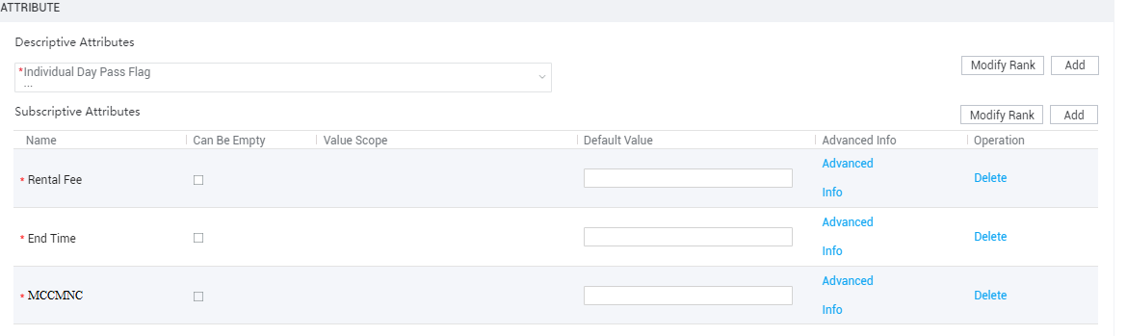

    - <Screen / Operation 1: subscribe or configure offer in SOP>
<Describe the current handling or behaviour this screen reuses.>
UI example as below:

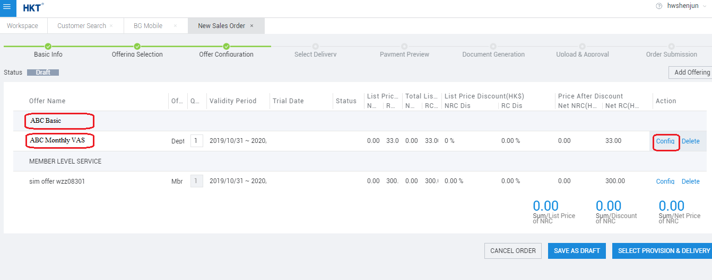

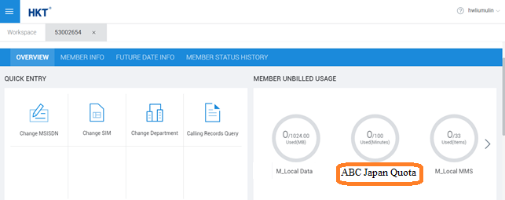

    - <Screen / Operation 2: view subscribed offer attributes in CSP/ESP>
<Screen: view subscriptive attributes of <Offer A> in CSP as below>

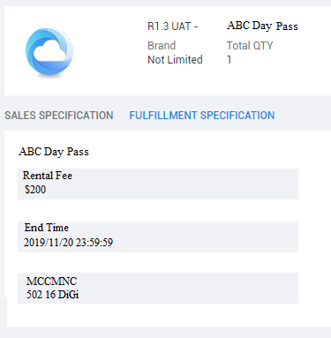

Element | Type | Description | Validation Rule | Action | Action Description | Remarks
<Field 1 Name> | Label | Indicate <field description> | - | Read-Only | -
<Field 2 Name> | Label | Indicate <field description> | - | Read-Only | -
<Field 3 Name> | Label | Indicate the <Field 3 Name>  <value format / example> | - | Read-Only | -

<Screen: view subscriptive attributes of <Offer B> in CSP as below>

Element | Type | Description | Validation Rule | Action | Action Description | Remarks
<Field 1 Name> | Label | Indicate <field description> | - | Read-Only | -
<Field 2 Name> | Label | Indicate <field description> | - | Read-Only | -
<Field 4 Name> | Label | Indicate <field description> |  | Read-Only | -

<Screen: view subscriptive attributes of <Offer A> in ESP as below>

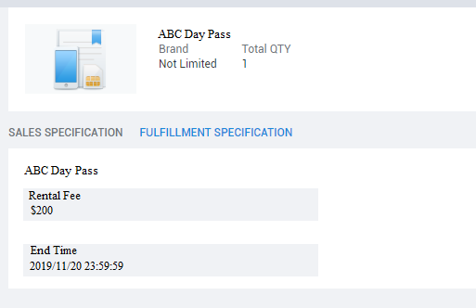

Element | Type | Description | Validation Rule | Action | Action Description | Remarks
<Field 1 Name> | Label | Indicate <field description> | - | Read-Only | -
<Field 2 Name> | Label | Indicate <field description> | - | Read-Only | -
<Note: <any screen-specific note, e.g. field X is not shown in ESP view>.>

<Screen: view subscriptive attributes of <Offer B> in ESP as below>

Element | Type | Description | Validation Rule | Action | Action Description | Remarks
<Field 1 Name> | Label | Indicate <field description> | - | Read-Only | -
<Field 2 Name> | Label | Indicate <field description> | - | Read-Only | -
<Field 4 Name> | Label | Indicate <field description> |  | Read-Only | -

ESP UI example as below:

    - <Screen / Operation 3: view subscribed <offer type> in CSP/ESP>

CSP UI example as below:

Element | Type | Description | Validation Rule | Action | Action Description | Remarks
<Field Name> | Label | <Field Name>  Indicate <field description> | - | Read-Only | -
<Note: <any deferred or cross-CR note>.>

Impact on the System
None

Application Limitations
1. FUP handling of <offers> will be handled in R1.4 discussion (to be included in R1.4 FUP FRS)

2. CSP/ESP SSO/link to <Feature Name> portal will be discussed in R1.4/ R1.3 CV8 (whichever earlier)

References
- <Reference document / offer list name for reference.>

- <Other reference material, offer list, or supporting document.>

Appendix

Unified API Interface Specification

KJava Interface Specification & Sample

CBS API Interface Specification (Notification to <External Platform>)

